HW1 Statistics
Posted Feb 4, 2019 8:16 PM
Dear EE569 Students,
Please find the attached figure for some statistics of HW1.
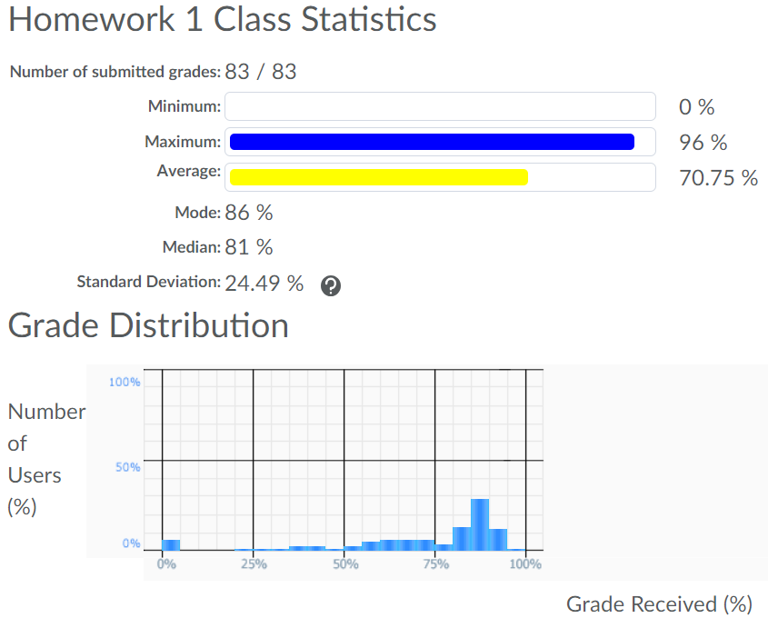
s

